Team 29: Design Documentation
Static Architecture

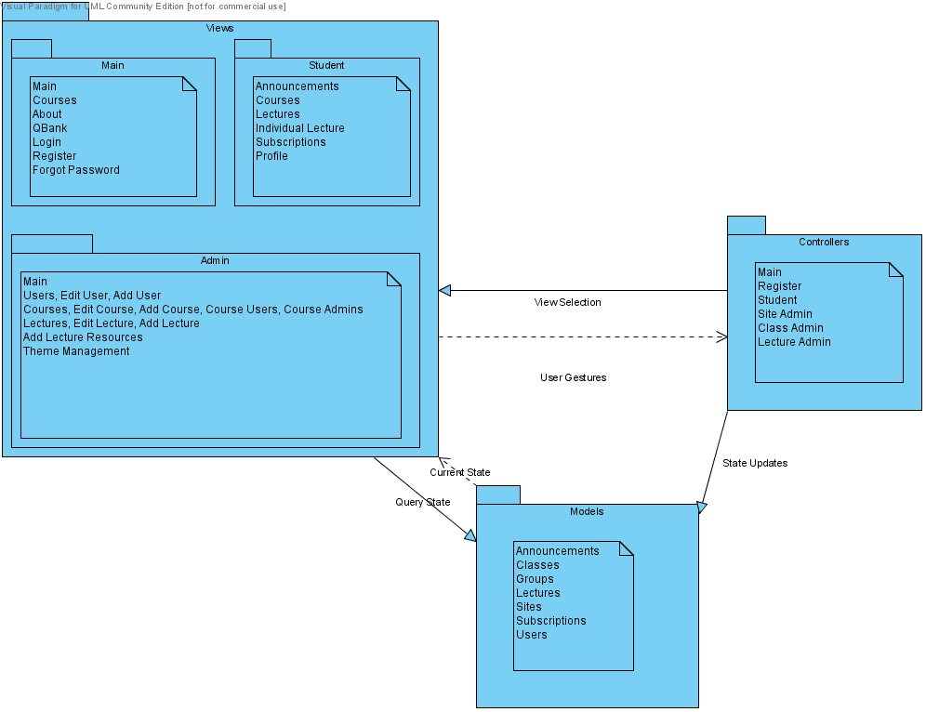

This is the conceptual drawing of our architecture pattern. The model handles communication with the database. The view and controller can talk with the models to obtain database information. At runtime, the controllers build the views and display them to the user.

Dynamic Architecture
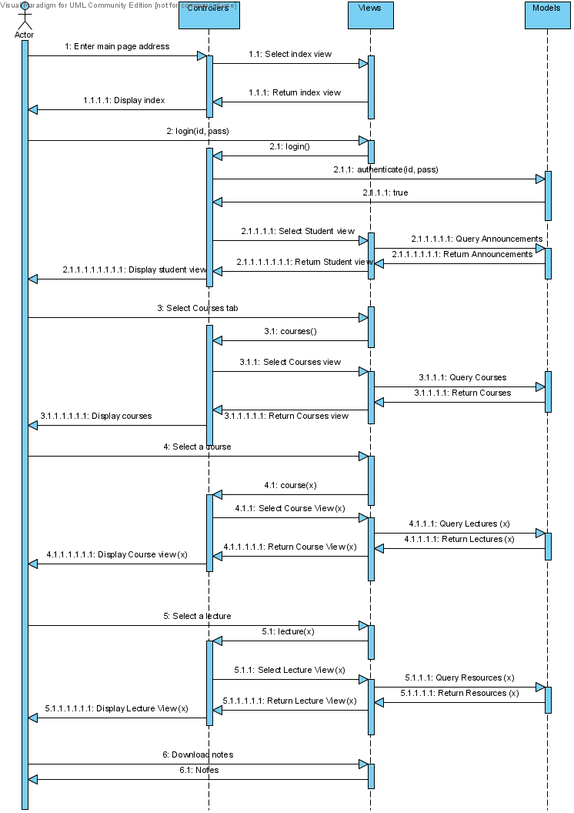
Rationale

We are using a Model-View-Controller (MVC) architecture design pattern along with Client-Server. Both architectures are ideal for the web application we intend to create. MVC allows the user interface to easily be changed, or to have multiple views. One of our requirements is customizability, and MVC will allow the user to change the appearance of the pages. Also, multiple pages may be able to use the same model objects. Client-Server will allow us to store all data on a server, which will give us more control over the security of the data. Only designated users should be able to view the material associated with a course, and those users should not be able to easily download the video and slide shows. Client-Server also allows for the server to be replaced/upgraded without the clients knowing, and data updates are fairly simple. The design will function with clients of different capabilities.

There are some disadvantages associated with these two models. MVC adds some additional complexity to the coding, and frequent model changes could result in a lot of view updates, slowing down the system. Client-server could be problematic if the server fails or if there is congestion on the network.

We also considered using a layered architecture plan with 3 layers: presentation, business, and data. This architecture plan has many of the same benefits of MVC. However, layered models are typically very linear, so a presentation layer would go through the business layer to get to the data level, and then the response would go through the business layer once again. With MVC, the view can query the model directly and get a response directly. Also, there are many web frameworks available that help implement MVC.

Data Design: ER Diagram
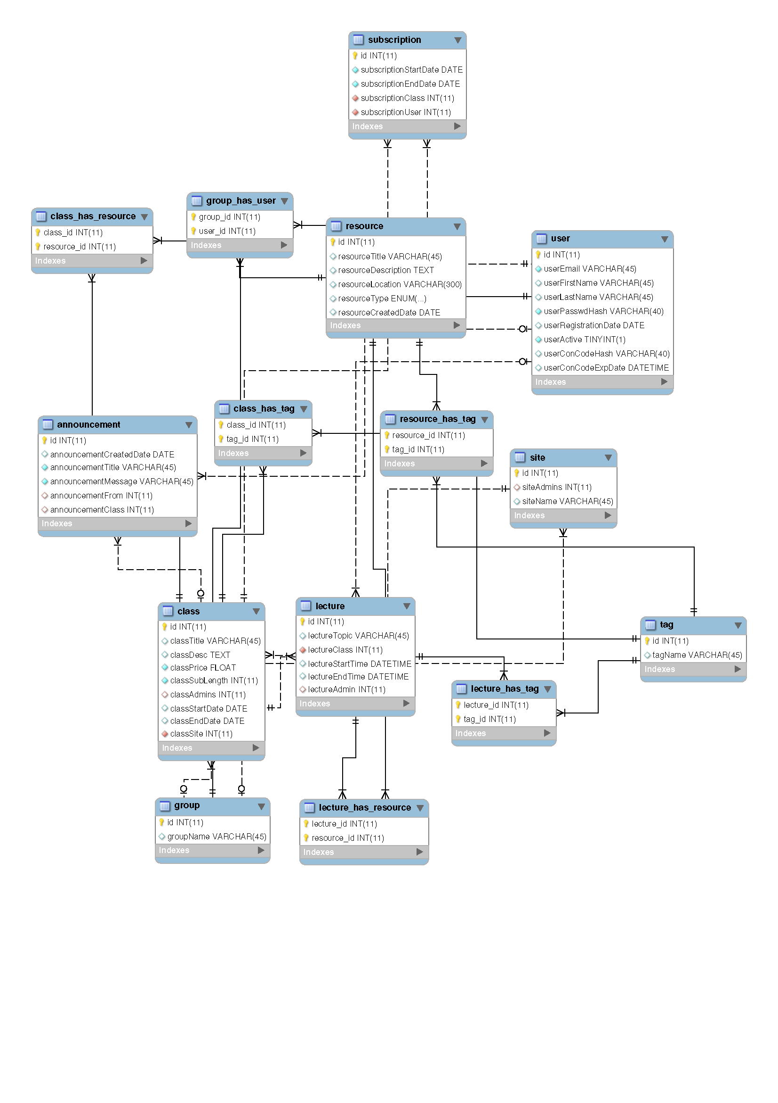

Detailed Design: Navigation Chart

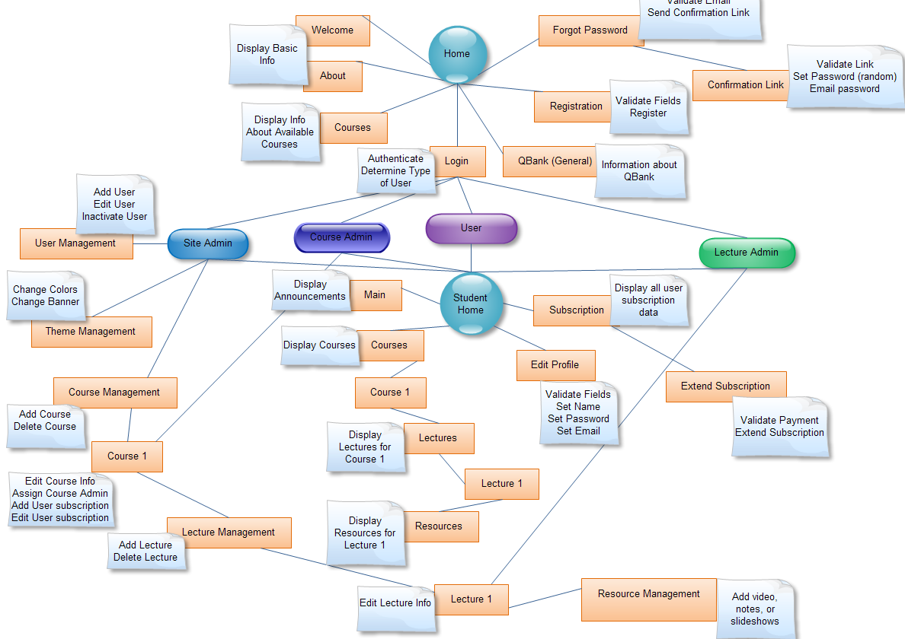

This navigation chart depicts our website. From each of the major nodes (Home, User, Lecture admin, etc), users can see what pages each nodes have access to and how one would get to a certain page.

Home
Welcome, About, and Courses | Displays basic information
QBank | Information about qbank, and a potential link to qbank
Login | Allows user to login with a username and password. Users, lecture admins, course admins, and site admins all login here
Registration | Allows registration. Will have to pay to sign up for courses, and payment must be confirmed
Forgot Password | Validate email and send confirmation link to email
Confirmation Link | Verify confirmation link, reset password to random password, and email new password

User
Subscription | Can view subscription length
Extend Subscription | Can extend subscription after payment confirmation, or if price is $0
Courses | Choose which course you want to view from a table
Lectures | View a table of lectures associated with the course. When the user clicks on a table row, they are moved to the page associated with that lecture
Resources | Displays the notes, videos, and slides associated with that lecture

Lecture Admin
Student Home | Lecture admins can see everything that a user can
Lecture 1 | Can edit lecture information of lecture they are assigned to
Resource Management | Can upload video, notes, or slides associated with a lecture that the lecture admin oversees

Course Admin
Student Home | Course admins can see everything that a user can
Course 1 | Can edit course info, add user subscription, or edit user subscription to course assigned to
Lecture Management | Can add and delete Lectures for the course assigned to
Lecture 1 | Can edit every lecture in course assigned to. This includes assigning lecture admins
Resource Management | Can upload video, notes, or slides associated with a lecture that is in the course they are assigned to

Site Admin
Student Home | Site admins can see everything that a user can
User Management | Add users, edit user info, inactivate users
Course Management | Can add a course, edit course info, or delete a course. Can Assign course admins
Theme Management | Can change colors and banner of site
Course and Lecture admins | Site admins can do everything course and lecture admins can

UI Mockups: Home

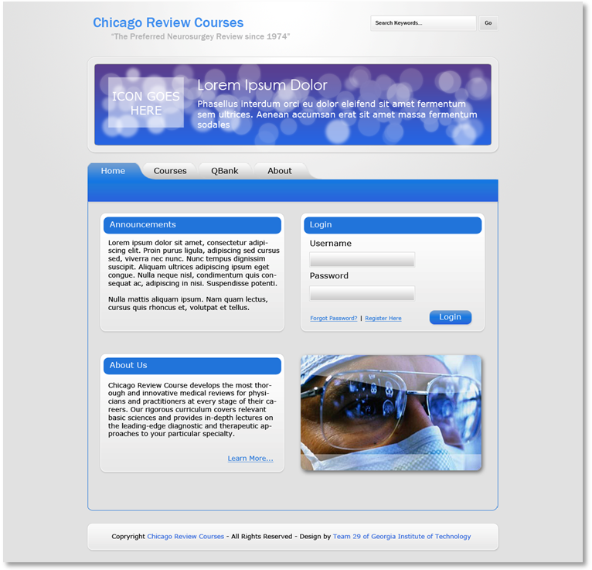

This is the home page that everyone with an Internet connection will have access to. The home page will contain a little information about Chicago Review Courses, and allow you to log in. You can also learn more by going to the About tab, which will have more in-depth information on Chicago Review Courses. The QBank tab will talk about QBank, which is a resource that users of this system may be able to use. The Courses tab will list the current courses and previous courses. Forgot password will allow you to reset your password, and register will allow you to register.
UI Mockups: User View (Schedule)

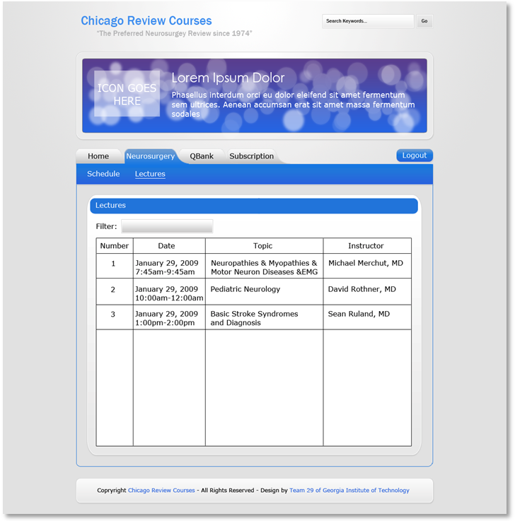

This is the normal user (student) view once you log in. The pages in this section are only accessible to registered users. This view right here is showing a list of lectures for the Neurosurgery Course. If you click on one of those rows, you will be taken to the next page. You can filter and sort the table.

UI Mockups: User View (Lecture video)

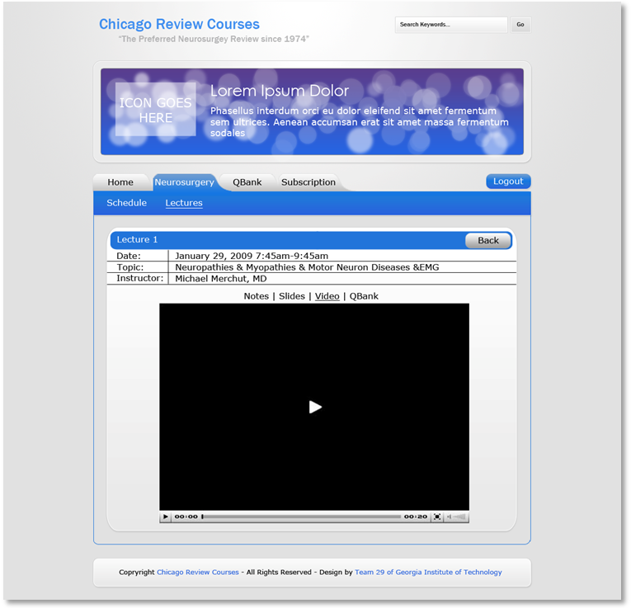

This is the lecture resource view, which appears when you select a lecture. You can view slides, notes, and video associated with the lecture. The QBank aspect of this page has actually been dropped and won’t be used. Ideally, the video will stream, and will not be (easily) downloadable. The same goes for the slides.

UI Mockups: User View (Subscriptions)

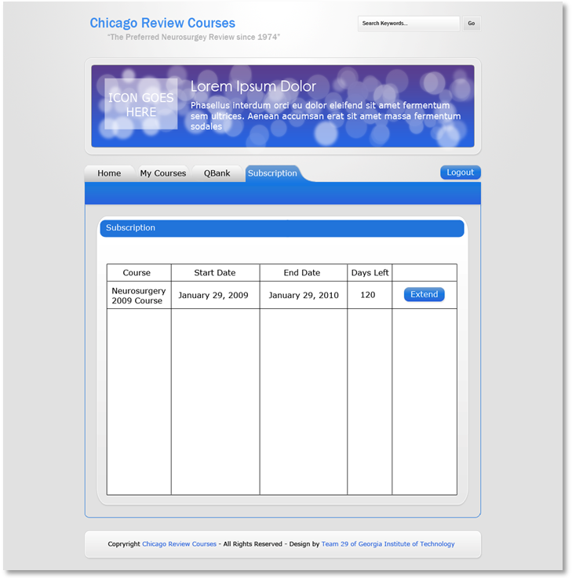

This is the view if you select the Subscription tab. Here you can view your subscriptions and extend them if you want to. When you click extend, you are taken to another page that list the price and other extension terms. You then pay through PayPal if the price is greater than zero.
Validation

We will be using requirements tracing to ensure our design meets the client’s requirements. W will go through a design review and inspection to make sure it meets the intended goal. To ensure we meet non-functional requirements, we will walk through the system design to determine if we can adequately meet our security, performance, availability, and usability needs.

